This template should be loaded as a Word add-in, by copying to the Word startup folder. If you have not changed the default startup folder it can be located (in English language versions of Windows) by typing
%appdata%\Microsoft\Word\Startup
in the Windows File Explorer Address bar and pressing Enter.


Insert Tab
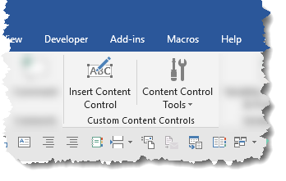

Developer Tab
